Learners have to develop a Report to support the answers to the following questions and suggestions.

Objective Questions:
- What is the total number of attributes in the customer table?
Ans : There 3 attributes in the customer table
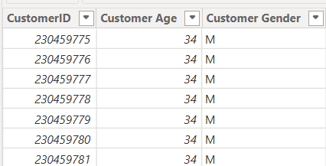

- How will you get the “Customer’s” ages in the “Order” tables according to customer IDs?
Ans :
- We will create one-to-many relationship between the Customers and Orders tables using CustomerID, then customer's age can be retrieved into the Orders table using the RELATED() DAX function:
Customer Age = RELATED(Customers[Customer Age])
- The RELATED() function fetches the corresponding Customer Age from the Customers table based on the existing relationship.
- In analyzing the dataset with Power BI, ensure data cleaning to address inconsistencies and missing values before further analysis.
Ans :
- Handled null values by replacing blank Reason values with "Not Applicable" and removing records with critical missing values where required.
- Removed duplicate records based on OrderID.
- Corrected data types for date, numeric, and currency columns.
- Created calculated columns such as Revenue, Delivery Days, Age Group, and Needs Improvement.
- Established a relationship between Customers and Orders using CustomerID.
- Created DAX measures including Total Revenue, Total Sales, Total Orders, Total Customers, Average Rating, Return Rate, Customer Satisfaction, and Average Delivery Days.
- Implemented a Field Parameter (Metric Selector) to dynamically switch between business metrics in visuals.
- How can we calculate the total revenue generated by all the sales?
Ans :
- The total revenue generated by all sales can be calculated by multiplying the Sale Price by the Order Quantity for each order and then summing the results.
- DAX Measure:
Total Revenue = SUMX(Orders, Orders[Sale Price] * Orders[Order Quantity] )
- Formula:
Total Revenue = Σ (Sale Price × Order Quantity)

- What is the total number of unique customers who made purchases each year? Is there any increase in the number over the years?
Ans :
- The total number of unique customers who made purchases during the analysis period is 113K. From 2015 to 2017, the number of unique customers remained relatively stable at approximately 17.6K customers per year. It slightly decreased to 17,352 in 2018, increased marginally to 17,536 in 2019, and then showed a significant rise to 22,305 in 2020. Overall, the analysis indicates a substantial increase in the number of unique customers in the final year.

- Visualization :
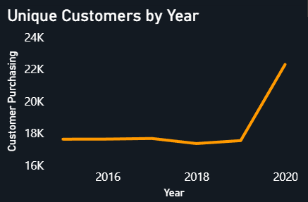

- How can we determine the total number of unique products available in the company?
Ans:
- The total number of unique products can be determined using the DISTINCTCOUNT() function on the Product column.
- DAX Measure:
Unique Products = DISTINCTCOUNT(Orders[Product])
- Visualization:
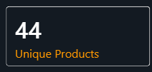
This measure counts each product only once, regardless of how many times it was sold.
- What is the average number of days it takes for products to be delivered, get the metric for only the delivered orders.
Ans :
- The average number of days it takes to deliver products is calculated by averaging the Delivery Days for delivered orders only. This metric is displayed using the Average Delivery Days KPI, which shows an average delivery time of approximately 9.4 days.
- Visualization
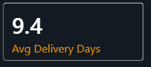
- Which products, categories, and subcategories are the most popular?
Ans :
The most popular products, categories, and subcategories were identified using the Top 5 Products by Revenue, Revenue by Product Category (Treemap), and Product Performance Scorecard visuals.
- Most Popular Product: Amazon Fire HD 8 Kids Tablet 32GB HDD - 2GB RAM - 8" Blue, as it generates the highest revenue among all products.
- Most Popular Category: Phones and Tablet, as it contributes the highest total revenue compared to other categories.
- Most Popular Subcategory: Tablets, as it contains the highest-performing products and generates the highest revenue within the selected category.

Visualizations
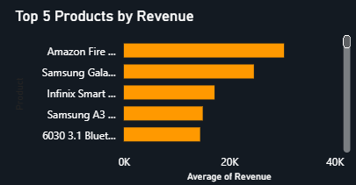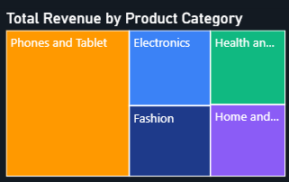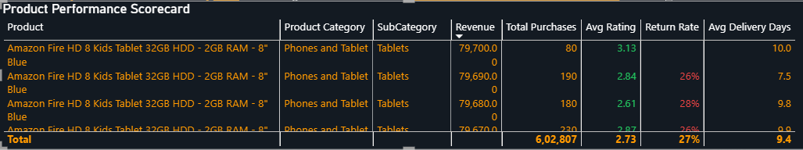
- Which products have seen an increase or decrease in sales over the year?
Ans :
- Among the products analyzed, the Amazon Fire HD 8 Kids Tablet 32GB HDD - 2GB RAM - 8" Blue (the highest revenue-generating product) showed an overall increase in sales over the years. Sales declined slightly from 2015 to 2016, increased in 2017, dipped marginally in 2018, and then grew steadily in 2019, reaching the highest sales in 2020. This indicates a strong positive sales trend for the product over the analysis period.
- Visualization:
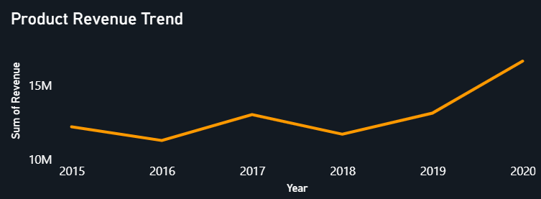

- While modeling the data relationships, what will be the type of relationship between the customer ID of Orders and customer tables?
Ans :
- The relationship between Orders[CustomerID] and Customers[CustomerID] is a One-to-Many (1:*) relationship.
- Customers is the One (1) side because each CustomerID is unique.
- Orders is the Many (*) side because a single customer can place multiple orders.
- Relationship:
Customers (1) ─────── (*) Orders
CustomerID CustomerID
This relationship allows customer information (such as Customer Age and Customer Gender) to be associated with every order.
- How have you handled the null values in the data?
Answer :
- Replaced blank/null values in the Reason column with "Not Applicable".
- Removed records containing critical null values that could affect the analysis.
- Verified that key fields such as OrderID, CustomerID, Product, Order Date, Status, and Revenue contained no null values before building the dashboard.
- Were there any data format issues in the data, and if there were/are how you would handle them?
Answer :
Yes. The data contained some formatting inconsistencies, which were resolved before analysis by:
- Converting Order Date and Delivery Date to the Date data type.
- Converting Order Quantity, CustomerID, and OrderID to Whole Number.
- Converting Sale Price, Unit Price, and Revenue to Decimal/Currency format.
- Ensuring categorical fields such as Product Category, Status, and Delivery Type were stored as Text.
- Replacing blank values with appropriate values (e.g., "Not Applicable" in the Reason column) to maintain data consistency.

- When we add a column in Power Query what’s the code that comes in M language in the formula bar? What do you know about M-query?
Answer :
- When a custom column is added in Power Query, an M language expression is generated in the formula bar. For example:
= Table.AddColumn(#"Previous Step", "New Column", each [Sale Price] * [Order Quantity])
- About M Query:
  - M Query (Power Query Formula Language) is the scripting language used in Power Query for data extraction, transformation, and loading (ETL).
  - It is case-sensitive and functional in nature.
  - Every transformation (such as filtering rows, changing data types, merging tables, replacing values, adding columns, or removing duplicates) is stored as an Applied Step and represented as M code.
  - M Query is executed before the data is loaded into the Power BI data model, making data preparation efficient and reproducible.
- Identify the top 5 most valuable customers using a composite score that combines three key metrics: (SQL)
  - Total Revenue (50% weight): The total amount of money spent by the customer.
  - Order Frequency (30% weight): The number of orders placed by the customer, indicating their loyalty and engagement.
  - Average Order Value (20% weight): The average value of each order placed by the customer, reflecting the typical transaction size.

Answer :
- SQL query and output :
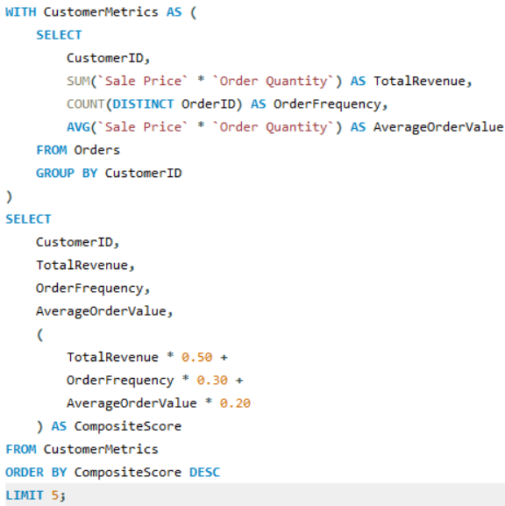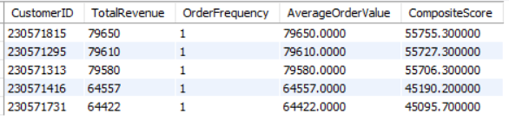
- Insights:
  - Customers 230571815, 230571295, and 230571313 have the highest composite scores, making them the most valuable customers.
  - The ranking is primarily driven by Total Revenue, as every customer in the dataset has placed only one order.
  - Since Order Frequency = 1 for all customers, Average Order Value equals Total Revenue, causing the composite score to be dominated by the revenue component.
  - These high-value customers are ideal candidates for premium loyalty programs, personalized offers, and targeted retention campaigns to maximize customer lifetime value.
- Calculate the month-over-month growth rate in total revenue across the entire dataset. (SQL)
Answer :
SQL Query and Output :
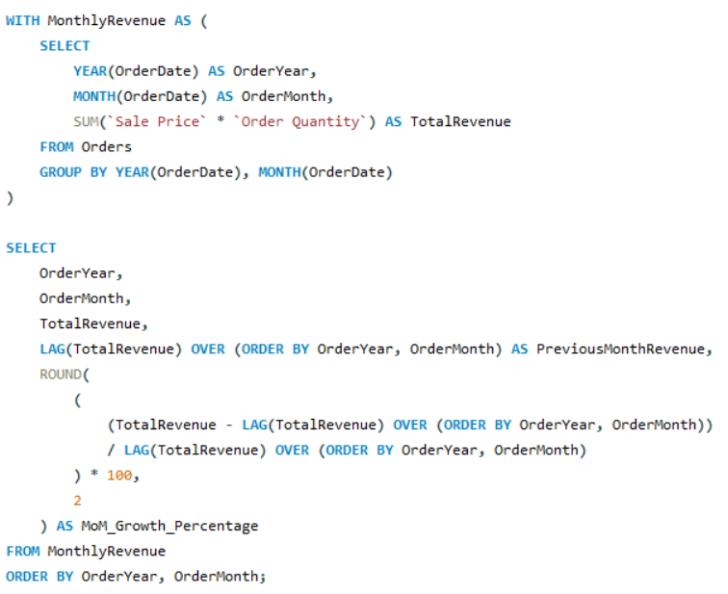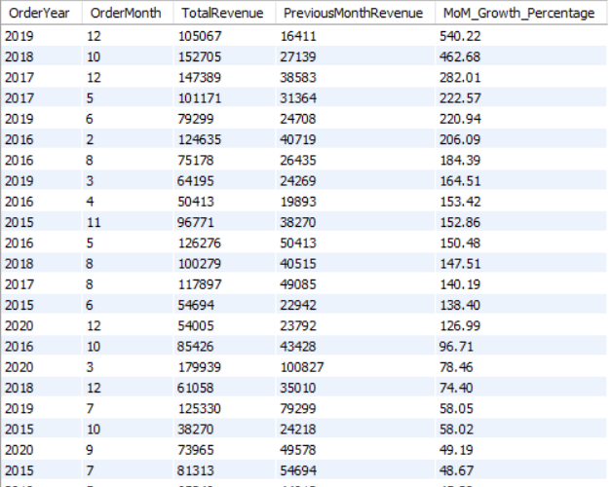

Insights

The analysis reveals significant fluctuations in month-over-month revenue growth throughout the period from 2015 to 2020, indicating varying customer demand and seasonal purchasing behavior.
    - The highest positive MoM growth was observed in December 2019 (540.22%), suggesting a substantial increase in revenue, likely driven by festive or year-end promotional sales.
    - Other notable revenue increases include October 2018 (462.68%), December 2017 (282.01%), and February 2016 (206.09%), indicating periods of exceptional sales performance.
    - Several months experienced negative growth, such as September 2018 (-72.94%), November 2018 (-77.07%), and November 2020 (-67.20%), reflecting temporary declines in monthly revenue.
    - Overall, the revenue trend demonstrates cyclical growth and decline, emphasizing the importance of monitoring monthly performance to understand seasonal demand patterns and customer purchasing behavior.

Recommendations
  - Plan marketing campaigns and promotional offers during months that historically show declining revenue to stabilize sales performance.
  - Analyze the factors contributing to high-growth months (e.g., festive seasons, discounts, or product launches) and replicate successful strategies in future campaigns.
  - Improve inventory planning and supply chain management before anticipated high-demand periods to prevent stock shortages.
  - Continuously monitor Month-over-Month growth to identify emerging sales trends and support data-driven business decisions for forecasting and resource allocation.
- Calculate the rolling 3-month average revenue for each product category. (SQL)
Answer:
- SQL Query and Output:
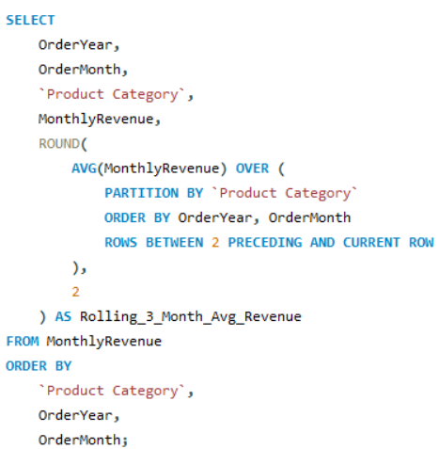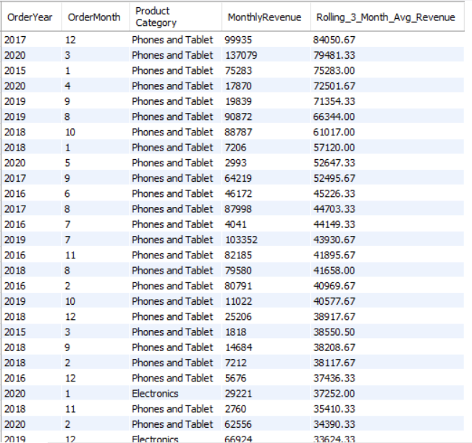

Insights:

The Phones and Tablet category records the highest rolling 3-month average revenue, with an average of ₹32,690 and a peak of ₹84,050.67 in December 2017, indicating that it is the most consistent revenue-generating category.
    - Electronics ranks second with an average rolling revenue of approximately ₹15,639, reaching its highest value (₹37,252) in January 2020, demonstrating stable long-term growth.
    - Home and Office, Health and Beauty, and Fashion have comparatively lower rolling averages (₹12,349, ₹11,089, and ₹10,671, respectively), indicating moderate and relatively stable sales performance.
    - The rolling average smooths monthly fluctuations, making it easier to identify sustained revenue trends rather than temporary monthly spikes.
    - Overall, the analysis highlights Phones and Tablet as the strongest-performing category, while Fashion and Health and Beauty show the greatest opportunity for revenue growth.

Recommendations
- Continue investing in Phones and Tablet through premium product launches, inventory availability, and targeted marketing to sustain its strong performance.
- Expand promotional campaigns and cross-selling strategies for Electronics to capitalize on its upward revenue trend.
- Introduce category-specific discounts, bundle offers, or seasonal promotions for Fashion, Health and Beauty, and Home and Office to improve their long-term sales performance.
- Use the 3-month rolling average as a key KPI for demand forecasting, inventory planning, and evaluating category performance, as it provides a more reliable view than monthly revenue alone.
- Update the orders table to apply a 15% discount on the `Sale Price` for orders placed by customers who have made at least 10 orders. (SQL)
Answer:
- SQL Query :
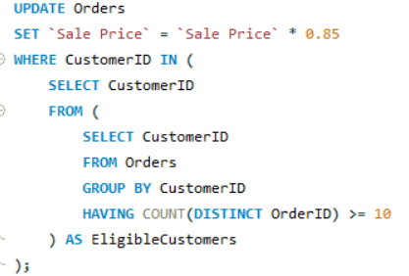
- Result: No records were updated because the dataset contains only one order per customer. Hence, no customer met the eligibility criterion of placing at least 10 orders.

- Calculate the average number of days between consecutive orders for customers who have placed at least five orders. (SQL)
Answer:
SQL Query and Output :
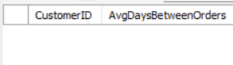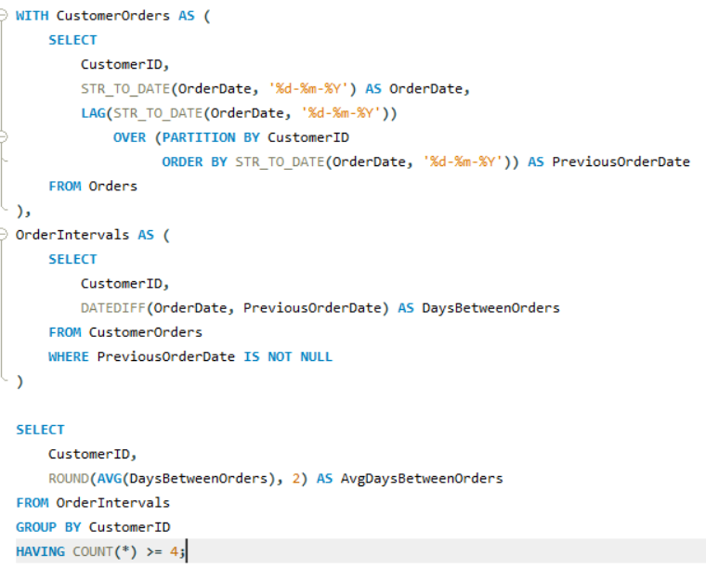
Result: No rows were returned because the dataset contains only one order per customer. Since there are no repeat orders, it is not possible to calculate the time interval between consecutive purchases.
- Identify customers who have generated revenue that is more than 30% higher than the average revenue per customer. (SQL)
Answer:
SQL Query and Output
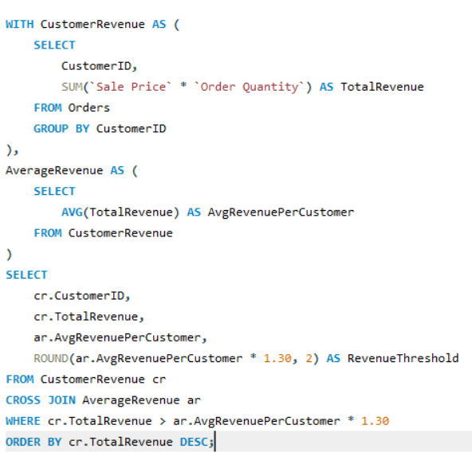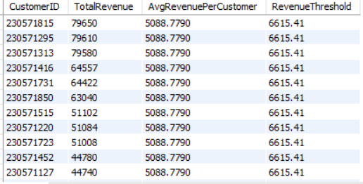

Insights
- The average revenue generated per customer is ₹5,088.78, and customers generating more than ₹6,615.41 are considered high-value customers.
- A total of 193 customers exceed this threshold, indicating a significant segment of customers contributes substantially more revenue than the average.
- The highest revenue-generating customer generated ₹79,650, which is more than 15 times the average revenue per customer.
- Since the dataset contains one order per customer, the revenue reflects the value of each customer's single purchase rather than cumulative spending across multiple transactions.

Recommendations
- Introduce VIP loyalty programs and exclusive benefits for these high-value customers to improve retention.
- Offer personalized product recommendations, premium support, and early access to new products to increase customer lifetime value.
- Analyze the purchasing patterns of these customers to identify common product categories and replicate successful marketing strategies.
- Encourage medium-value customers to move into the high-value segment through targeted promotions, bundle offers, and personalized discounts.
- Determine the top 3 product categories that have shown the highest increase in sales over the past year compared to the previous year. (SQL)
Answer:
- SQL Query and Output
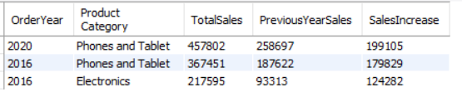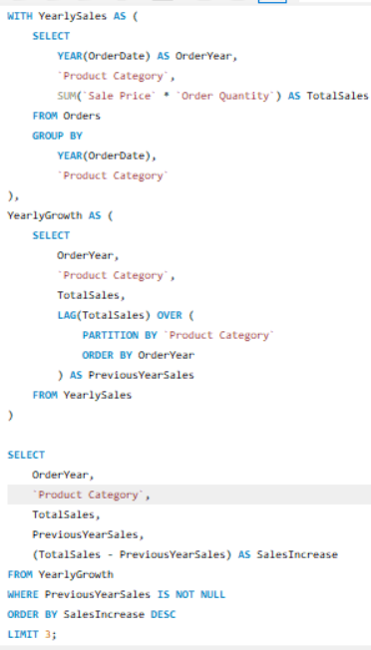

- Insights
  - Phones and Tablet emerged as the fastest-growing product category, recording the highest year-over-year sales increase of ₹199,105 in 2020, compared to the previous year.
  - The Phones and Tablet category also experienced significant growth in 2016, with sales increasing by ₹179,829, indicating sustained customer demand over multiple years.
  - Electronics ranked third, achieving a sales increase of ₹124,282 in 2016, reflecting strong market performance and growing customer interest.
  - The results indicate that technology-related product categories consistently outperform other categories, making them major contributors to overall revenue growth.

Recommendations
  - Continue investing in the Phones and Tablet category by expanding product offerings, maintaining sufficient inventory, and launching targeted promotional campaigns.
  - Strengthen marketing efforts for the Electronics category through seasonal discounts, bundled offers, and cross-selling opportunities.
  - Analyze the factors driving growth in these categories, such as pricing strategies, product launches, or customer preferences, and apply similar approaches to lower-performing categories.
  - Allocate a larger share of marketing and inventory resources to these high-growth categories while developing improvement strategies for categories with slower growth.

Subjective Question:
- Explain the revenue breakdown by year and by-product. Evaluate how different products contribute to annual revenue and come up with suggestions to increase the sales of the low-selling items.
Answer:

Visualization Used
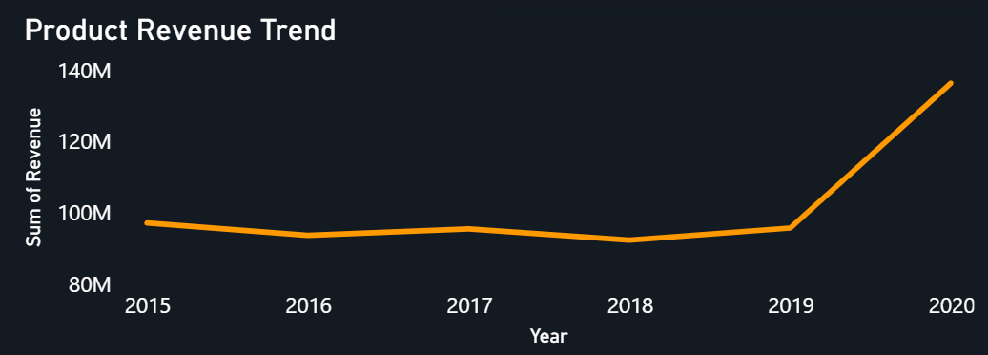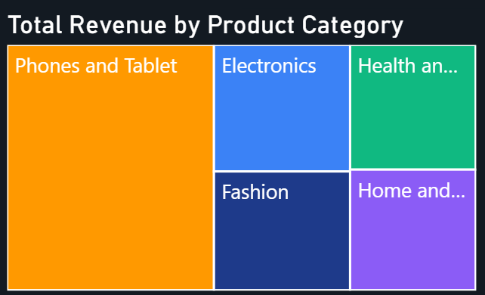
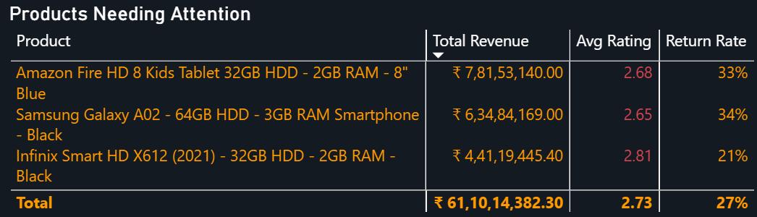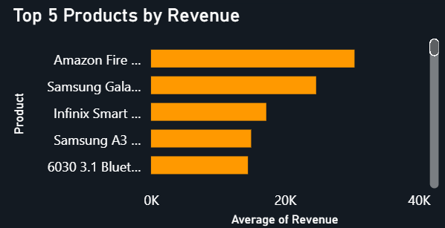

Insights
  - Annual revenue remained relatively stable between 2015 and 2019, followed by a significant increase in 2020, indicating strong business growth in the final year.
  - Phones and Tablet is the highest revenue-contributing product category, followed by Electronics, while Home and Office and Other contribute comparatively less.
  - The Amazon Fire HD 8 Kids Tablet 32GB HDD – 2GB RAM – 8" Blue is the highest revenue-generating product, followed by the Samsung Galaxy A02 and Infinix Smart HD X612 (2021).
  - Although these products generate high revenue, they also exhibit low average ratings (2.65–2.81) and high return rates (21%–34%), highlighting opportunities for quality improvement and customer satisfaction.

Recommendations
  - Improve product quality and packaging to reduce return rates.
  - Analyze customer feedback to address recurring product issues.
  - Increase the visibility of low-selling products through targeted digital marketing and personalized recommendations.
  - Introduce promotional discounts, bundle offers, and optimized pricing strategies to improve sales of underperforming products.
  - Continuously monitor product performance using revenue, ratings, and return rates to support data-driven business decisions.
- How many products were returned? Use a DAX function to get this metric. Examine the possible reasons for returns and consider how this metric could indicate improvements in product descriptions or quality control.
Answer :

DAX Measure
Returned Products =
CALCULATE (
COUNT ( Orders[OrderID] ),
Orders[Status] = "Returned"
)

Visualization Used
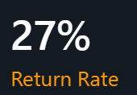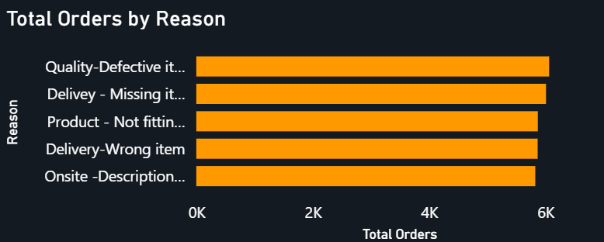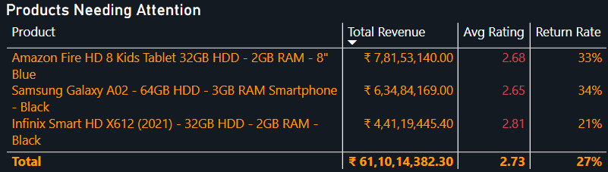

Insights
  - The dashboard shows an overall Return Rate of 27%, indicating that more than one-fourth of the orders were returned.
  - The leading reasons for returns are Quality – Defective Item, Delivery – Missing Item, Product – Not Fitting Description, Delivery – Wrong Item, and Onsite – Description Mismatch, each contributing a significant number of return orders.
  - Products such as Amazon Fire HD 8 Kids Tablet, Samsung Galaxy A02, and Infinix Smart HD X612 (2021) have relatively high return rates (33%, 34%, and 21%, respectively), suggesting that even high-revenue products face customer satisfaction and quality issues.

Recommendations
  - Improve product quality through stricter quality control before shipment.
  - Provide accurate product descriptions, specifications, and images to reduce expectation mismatches.
  - Strengthen warehouse and logistics processes to minimize wrong or missing item deliveries.
  - Continuously monitor return reasons and customer feedback to identify recurring issues and reduce future return rates.
- Whenever a customer goes to Amazon, they’ll filter the most rated products to buy the better category. Can you verify this using any visualization or table that the ratings of products impact their sales value?
Answer :

Visualization Used
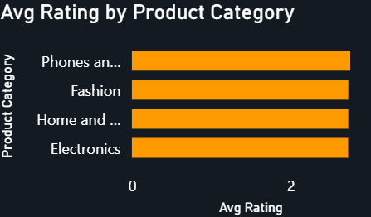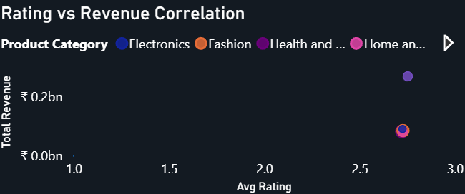

Insights
  - The Rating vs Revenue Correlation scatter plot indicates a positive but not perfect relationship between product ratings and sales revenue.
  - The Phones and Tablet category has the highest average rating (2.75) and also contributes the highest revenue, suggesting that better-rated categories generally attract more customer purchases.
  - Fashion, Home and Office, and Electronics have very similar average ratings (2.73) but generate different levels of revenue, indicating that sales are also influenced by factors such as product demand, pricing, brand reputation, and promotions.
  - Therefore, product ratings positively influence sales, but they are not the only factor affecting revenue.

Recommendations
  - Improve product quality to achieve higher customer ratings and satisfaction.
  - Encourage customers to leave verified reviews after purchase.
  - Highlight highly rated products in search results and recommendations to increase customer confidence.
  - Analyze low-rated products and customer feedback to reduce returns and improve future sales.
- Investigate how revenue distribution varies across different locations. Explore which geographical areas contribute most to sales and consider the strategic implications for regional marketing and distribution efforts. How might location-based trends inform the company's market segmentation and resource allocation approach?
Answer :

Visualization Used
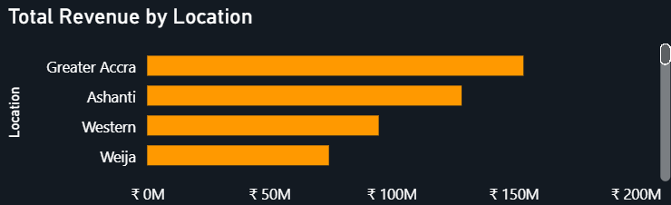

Insights
  - The Total Revenue by Location analysis shows that Greater Accra is the highest revenue-generating location, followed by Ashanti, Western, and Weija.
  - The significant difference in revenue across locations indicates that customer demand and purchasing behavior vary by region.
  - High-performing regions such as Greater Accra and Ashanti contribute the largest share of sales and represent the company's strongest markets, whereas Western and Weija have comparatively lower revenue, suggesting untapped growth opportunities.
  - These location-based trends can help the company segment markets according to regional demand and prioritize investments in high-potential areas.

Recommendations
  - Increase inventory, marketing budgets, and distribution resources in Greater Accra and Ashanti to maximize revenue from high-demand markets.
  - Launch targeted promotional campaigns and region-specific offers in Western and Weija to improve customer engagement and sales.
  - Analyze regional customer preferences to develop localized marketing strategies and optimize product assortment.
  - Continuously monitor location-wise sales performance to support effective market segmentation and data-driven resource allocation across different regions.
- Determine which month could benefit from enhanced promotional offers to boost sales. Can you suggest some targeted marketing strategies here?
Answer :

Visualization Used
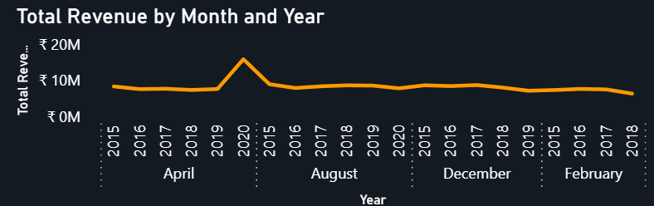

Insights
  - The monthly revenue trend shows that February records the lowest sales among the analyzed months, while April achieves the highest revenue.
  - Revenue remains relatively stable across most months, but the decline in February suggests lower customer demand or seasonal purchasing behavior.
  - Implementing promotional activities during low-performing months can help improve customer engagement and increase overall revenue.

Recommendations
  - Launch seasonal discounts and flash sales during February to stimulate customer demand.
  - Offer bundle deals by combining low-selling products with popular products.
  - Provide free shipping, cashback, or coupon offers to encourage purchases.
  - Run targeted email, SMS, and social media campaigns for existing customers.
  - Introduce personalized product recommendations and loyalty rewards to increase repeat purchases.
  - Increase digital advertising and influencer promotions during the low-sales period to improve product visibility and conversions.
- Identify which products may require increased marketing efforts. Which items have high prices yet underperform in sales?
Answer :

Visualization Used
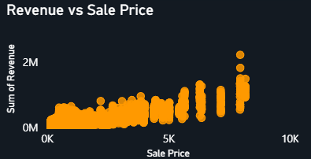

Insights
- The scatter plot shows a general positive relationship between Sale Price and Revenue, where higher-priced products tend to generate higher revenue.
- However, several high-priced products exhibit comparatively low revenue, indicating that premium pricing alone does not guarantee strong sales performance.
- These products are likely underperforming due to factors such as lower customer demand, limited product visibility, weaker customer ratings, or ineffective marketing strategies.
- Such products should be identified for closer performance monitoring and targeted business interventions.

Recommendations
- Launch targeted promotional campaigns for high-priced, low-selling products.
- Offer limited-time discounts, bundle deals, or EMI/payment options to improve affordability.
- Improve product descriptions, images, and feature highlights to increase customer confidence.
- Increase product visibility through personalized recommendations, sponsored listings, and digital marketing.
- Monitor customer feedback and ratings to identify product improvements that can enhance demand and sales.
- Assess which products should have discounts. How can targeted incentives drive sales and customer loyalty for specific products?
Answer :

Visualization Used

Insights
  - The Products Needing Attention table identifies products with low ratings and high return rates, making them suitable candidates for targeted discount campaigns.
  - The Revenue vs Sale Price scatter plot shows that some higher-priced products generate comparatively lower revenue, suggesting that price may be a barrier to purchase.
  - Products with lower ratings and weaker sales performance are less likely to attract repeat customers without additional incentives.
  - Rather than applying discounts across all products, discounts should focus on products that are high-priced, low-selling, or have higher return rates.

Recommendations
  - Offer limited-time discounts on high-priced, low-selling products to improve conversions.
  - Introduce bundle offers by pairing slow-moving products with best-selling products.
  - Provide loyalty rewards, coupons, and cashback offers to encourage repeat purchases.
  - Use personalized promotions based on customer purchase history and browsing behavior.
  - Monitor the impact of discount campaigns on sales, customer retention, and profitability to optimize future pricing strategies.
- Come up with a loyalty program to benefit the company’s customers. From the available lot of customers come up with strategies to bucket them and provide benefits under different loyalty programs.
Answer :

Visualization Used
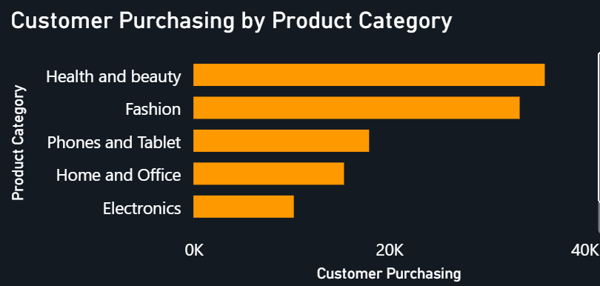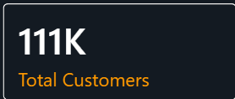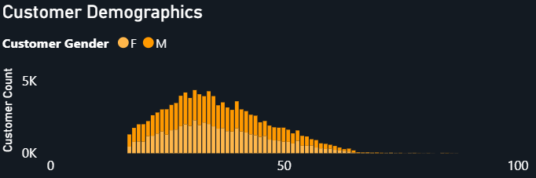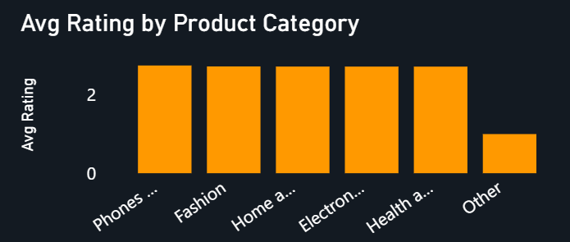

- Insights
  - The company serves approximately 113K customers, providing a large customer base for implementing a tiered loyalty program.
  - Health and Beauty and Fashion categories have the highest customer purchases, indicating strong customer engagement in these segments.
  - Customer demographics show that the majority of customers fall within the 25–45 age group, making them the primary target for personalized offers and retention campaigns.
  - The Phones and Tablet category has the highest average rating, suggesting that customers purchasing from this category are more satisfied and are good candidates for premium loyalty benefits.
Recommendations (Loyalty Program)
Loyalty Tier | Customer Bucket | Benefits
Bronze | New customers (1–2 purchases) | Welcome coupons, free shipping on first orders
Silver | Repeat customers (3–5 purchases) | Reward points, 5% discount, early sale access
Gold | Frequent customers (6–10 purchases) | 10% discount, cashback, priority delivery
Platinum | High-value customers (10+ purchases/high spending) | Exclusive product launches, premium support, maximum reward points, special member-only offers

Additional Strategies
  - Provide category-specific rewards for customers purchasing frequently from Health and Beauty and Fashion.
  - Recommend highly rated Phones and Tablet products to increase customer satisfaction and repeat purchases.
  - Send personalized offers based on purchase history and demographic segments.
  - Reward customers for writing product reviews and referring new customers to encourage engagement and long-term loyalty.

- Using the DAX functions Calculate and a row iteration DAX function calculate the total sales for the Product Category “Fashion” and delivery type “Shipped from Abroad”. What are the other types of DAX functions you have used in the project?
Answer :

Visualization Used


DAX Measure
Fashion Sales (Shipped from Abroad) =
CALCULATE(
SUMX(
Orders,
Orders[Revenue]
),
Orders[Product Category] = "Fashion",
Orders[Delivery Type] = "Shipped from Abroad"
)

Result
The total sales for the Fashion category with Delivery Type = Shipped from Abroad is ₹28.01 Million.

Other DAX Functions Used in the Project
DAX Function | Purpose
SUM() | Total Revenue, Total Sales
AVERAGE() | Average Rating, Average Delivery Days
COUNT() | Total Orders
DISTINCTCOUNT() | Total Customers, Unique Products
CALCULATE() | Filtered KPIs and category-specific calculations
SUMX() | Row-wise revenue calculation
DIVIDE() | Return Rate and Customer Satisfaction calculations
SWITCH() | Dynamic Metric Selector
SELECTEDVALUE() | Capture selected metric from slicer
IF() | Products Needing Attention calculated column
DATEADD() | Previous Month Revenue / MoM Growth calculations

- Wait Times Correlated with Demographics and Care: Explore how average wait times vary across different product categories to optimize scheduling and staffing.
Answer :

Visualization Used
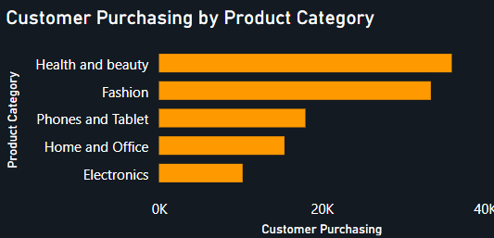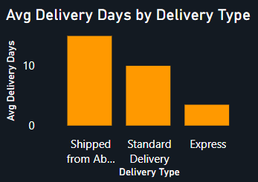

Insights
  - The analysis shows that Shipped from Abroad has the highest average delivery time (≈15 days), followed by Standard Delivery (≈10 days), while Express Delivery has the lowest average delivery time (≈4 days).
  - Health and Beauty and Fashion have the highest customer purchases, indicating that these categories require efficient logistics and timely deliveries to maintain customer satisfaction.
  - Longer delivery times, particularly for Shipped from Abroad, may negatively impact customer experience and increase the likelihood of cancellations or returns.
- Recommendations
  - Increase inventory for high-demand categories such as Health and Beauty and Fashion in local warehouses to reduce delivery time.
  - Expand the use of Express Delivery for frequently purchased products where feasible.
  - Optimize international shipping routes and warehouse allocation for Shipped from Abroad orders.
  - Continuously monitor delivery performance by category and delivery type to improve logistics efficiency, customer satisfaction, and resource allocation.
- Explore if there is any relationship between the Delivery type and waiting time between ordering and receiving an item.
Answer :

Visualization Used

Insights
  - The analysis indicates a clear relationship between Delivery Type and the waiting time for receiving an order.
  - Shipped from Abroad has the highest average delivery time (≈15 days), making it the slowest delivery option due to international shipping and customs processing.
  - Standard Delivery takes approximately 10 days, providing a balance between delivery speed and shipping cost.
  - Express Delivery has the shortest average delivery time (≈4 days), making it the fastest option for customers.
  - The findings demonstrate that the chosen delivery method has a significant impact on customer waiting time and overall shopping experience.

Recommendations
  - Encourage customers with urgent requirements to choose Express Delivery through promotional shipping offers.
  - Improve international logistics and warehouse planning to reduce delays in Shipped from Abroad orders.
  - Stock high-demand products in local fulfillment centers to minimize dependence on international shipping.
  - Regularly monitor delivery performance by delivery type to improve operational efficiency and customer satisfaction.
- Is there any relationship between shipping charges and product type?
Answer :

Visualization Used
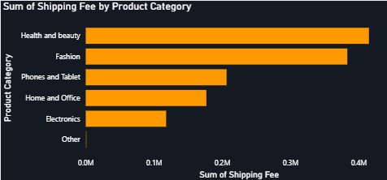

Insights
  - The analysis indicates that shipping charges vary significantly across different product categories.
  - Health and Beauty incurs the highest total shipping charges, followed by Fashion and Phones and Tablet.
  - Electronics and Home and Office contribute comparatively lower shipping charges, while the Other category has the least.
  - The variation in shipping charges suggests that product type influences shipping costs, likely due to differences in product volume, weight, packaging requirements, and shipping demand.

Recommendations
  - Optimize packaging and logistics for categories with high shipping costs, particularly Health and Beauty and Fashion.
  - Negotiate better shipping rates with logistics partners for frequently shipped product categories.
  - Introduce free shipping thresholds or category-specific shipping offers to improve customer satisfaction without significantly affecting profitability.
  - Continuously monitor shipping costs by product category to optimize pricing strategies and improve operational efficiency.
- Come up with strategies to decrease the low rating orders after analyzing different factors like waiting time, shipping type, unit price, etc.
Answer :

Visualization Used

Insights
  - Shipped from Abroad has the highest average delivery time (≈15 days), while Express Delivery has the shortest (≈4 days). Longer delivery times can negatively impact customer satisfaction and ratings.
  - The Revenue vs Sale Price scatter plot shows that although higher-priced products generally generate higher revenue, several premium-priced products do not perform well, indicating that customers expect better quality and value for expensive products.
  - The Products Needing Attention table highlights products with low average ratings (2.66–2.82) and high return rates (21%–33%), indicating recurring customer dissatisfaction.
  - The major reasons for returns are Quality – Defective Item, Delivery – Missing Item, Product – Not Fitting Description, Delivery – Wrong Item, and Onsite – Description Mismatch, all of which contribute to poor customer ratings.

Recommendations
  - Reduce delivery time for Shipped from Abroad orders by increasing local inventory and optimizing logistics.
  - Strengthen quality control to minimize defective products before dispatch.
  - Improve product descriptions, specifications, and images to accurately represent the product and reduce expectation mismatches.
  - Reassess the pricing of premium products to ensure customers perceive value for money.
  - Improve warehouse operations to reduce wrong-item and missing-item deliveries.
  - Regularly monitor customer reviews, ratings, and return reasons to identify recurring issues and implement corrective actions, thereby improving customer satisfaction and reducing low-rated orders.
- Using the time intelligence DAX function, create a table to compare each month’s sales with the previous year’s same month’s total sales. So there will be four columns in the output year, month, total sales, previous_years_sales.
Answer :

DAX Measures
Total Sales =
SUM(Orders[Revenue])
Previous Year's Sales =
CALCULATE(
[Total Sales],
SAMEPERIODLASTYEAR(DateTable[Date])
)

Visualization Used
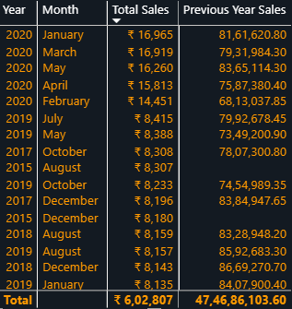

Insights
  - The table compares each month's sales with the corresponding month of the previous year using the SAMEPERIODLASTYEAR() Time Intelligence function.
  - This comparison helps identify seasonal trends and year-over-year growth or decline in monthly sales.
  - It enables the business to recognize high-performing months and periods where sales require improvement.

Recommendations
  - Increase promotional campaigns during months showing a decline compared to the previous year.
  - Replicate successful marketing strategies from months that demonstrate strong year-over-year growth.
  - Use the comparison to improve demand forecasting, inventory planning, and resource allocation.
  - Continuously monitor monthly performance to make data-driven business decisions and optimize sales strategies.
- What do you understand by PowerBI gateway? What are its use cases?
Answer :
- Power BI Gateway is a secure bridge that allows the Power BI Service (cloud) to connect to on-premises data sources such as SQL Server, Excel files, Oracle, or local folders without moving the data to the cloud. It enables Power BI reports and dashboards to access and refresh on-premises data securely.

Use Cases
  - Scheduled Data Refresh: Automatically refresh reports using the latest on-premises data.
  - Live Connectivity: Connect Power BI Service to on-premises databases in real time.
  - Secure Data Access: Keeps data within the organization's network while allowing cloud access.
  - Multiple Data Sources: Supports SQL Server, Oracle, SAP, Excel, SharePoint, and other on-premises sources.
  - Enterprise Reporting: Enables organizations to publish and share reports with up-to-date data without manually uploading datasets.
- How would you approach this problem, if the objective and subjective questions weren't given?
Answer :
I would follow a structured data analytics workflow:
- Understand the Dataset
  - Review all tables, columns, data types, and relationships.
  - Identify business entities such as Orders, Customers, Products, and Date.
- Perform Data Cleaning
  - Handle missing values and duplicates.
  - Correct data types and formats.
  - Create calculated columns where required (e.g., Age Group, Return Rate).
- Build the Data Model
  - Create relationships between fact and dimension tables.
  - Develop a Date Table for time intelligence analysis.
- Create KPIs
  - Total Revenue
  - Total Orders
  - Total Customers
  - Average Rating
  - Return Rate
  - Average Delivery Days
- Perform Exploratory Data Analysis (EDA)
  - Analyze sales trends over time.
  - Compare product categories and locations.
  - Study customer demographics and purchasing behavior.
  - Examine delivery performance, return reasons, and customer ratings.
  - Identify top-performing and underperforming products.
- Generate Business Insights
  - Determine revenue drivers.
  - Identify products requiring improvement.
  - Analyze customer behavior and regional performance.
  - Recommend strategies to improve sales, customer satisfaction, and operational efficiency.
- Build Interactive Dashboards
  - Design dashboards with KPIs, charts, filters, and drill-through navigation.
  - Add slicers and dynamic measures to enable business users to explore the data.

Conclusion
This approach ensures the data is first understood and prepared, then analyzed to uncover meaningful business insights, and finally presented through interactive dashboards to support data-driven decision-making.

